Design and Evaluation of an Automated Answer Assessment System Using OCR and Semantic Scoring

Toshan Kanwar

Design and Evaluation of an Automated Answer Assessment System Using OCR and Semantic Scoring

Thesis submitted to in partial fulfillment of the requirements for the degree

of

Bachelor of Technology

in

Data Science and Artificial Intelligence (DSAI)
by
Toshan Kanwar

Under the guidance of
Dr. Chandra Shekhar Nishad
Assistant Professor, Department of Science, and Mathematics

IIIT Naya Raipur



Dr. SPM International Institute of Information Technology Naya Raipur, India 493661
May 2026

2026 Toshan kanwar. All rights reserved.

Your Dedication
This work is dedicated to my parents, Family and Friends for their Support, Sacrifice Encouragement and love

Approval of the Viva-Voce Board

May 22, 2026

Certified that the thesis entitled Design and Evaluation of an Automated Answer Assessment System Using OCR and Semantic Scoring submitted by Toshan Kanwar to the Dr. SPM International Institute of Information Technology, Naya Raipur, India, for the award of the degree of Bachelor of technology has been accepted by the examiners and that the student has successfully defended the thesis in the viva-voce examination held today.

Dr. Chandra Shekhar Nishad
Assistant Professor (Department of Science, and Mathematics)
IIIT-Naya Raipur.

Dr. Abhishek Sharma Assistant Professor (Department of ECE) IIIT-Naya Raipur.

Dr. Santosh Kumar Associate Professor (Department of CSE) IIIT-Naya Raipur.

DECLARATION

May 22, 2026

I certify that

- The work contained in the thesis is original and has been done by myself under the general supervision of my supervisor.
- The work has not been submitted to any other Institute for any degree or diploma.

- I have followed the guidelines provided by the Institute in writing the thesis.

- I have conformed to the norms and guidelines given in the Ethical Code of Conduct of the Institute.
- Whenever I have used materials (data, theoretical analysis, and text) from other sources, I have given due credit to them by citing them in the text of the thesis and giving their details in the references.
- Whenever I have quoted written materials from other sources, I have put them under quotation marks and given due credit to the sources by citing them and giving required details in the references.

Toshan Kanwar Date: May 22, 2026

Certificate

This is to certify that the thesis entitled, Design and Evaluation of an Automated Answer Assessment System Using OCR and Semantic Scoring submitted by Toshan kanwar to Dr. SPM International Institute of Information Technology, Naya Raipur, Chhattisgarh, India, is a record of bona fide research work under my supervision and I consider it worthy of consideration for the award of the degree of Bachelor of Technology of the Institute.

Dr. Chandra Shekhar Nishad
Assistant Professor
(Department of Science, and Mathematics)
IIIT Naya Raipur

Acknowledgment

I would like to express my sincere gratitude to all those who have contributed to the completion of this project on the Design and Evaluation of an Automated Answer Assessment System Using OCR and Semantic Scoring.
First and foremost, I extend my deepest appreciation to Dr. Chandra Shekhar Nishad, my project supervisor, for their invaluable guidance, profound insights, and unwavering support throughout the entire duration of this project. Their expertise was crucial in overcoming technical challenges and shaping the direction of this research.
Finally, I would like to express my heartfelt appreciation to my family for their continuous encouragement and understanding during the demanding phases of this project.

May 22, 2026 Naya Raipur Toshan Kanwar

Plagiarism Report



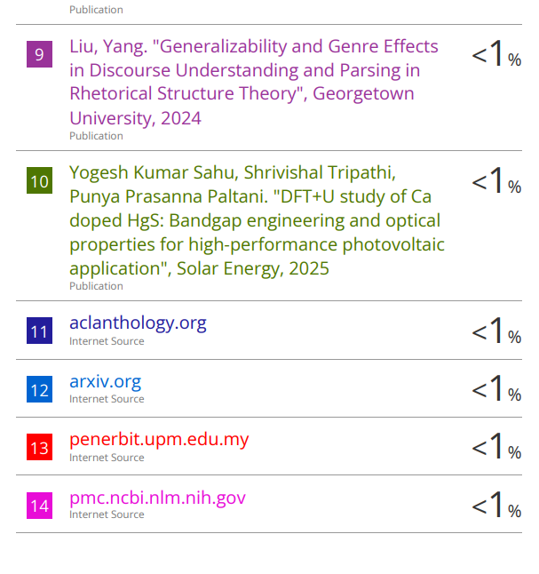

Abstract

This thesis investigates the design and development of an automated academic answer evaluation framework, AutoGrade, aimed at improving the efficiency, consistency, and scalability of conventional assessment practices. Manual evaluation of descriptive responses is often constrained by high turnaround time and evaluator-dependent variation, creating a need for systematic digital alternatives in higher education environments.

The proposed framework integrates document ingestion, OCR-based text extraction, algorithmic evaluation logic, and structured result generation within a unified web platform. The system is implemented using Next.js (presentation layer), FastAPI (application and service layer), and MongoDB (data layer). A modular processing pipeline is established to support answer-script upload, preprocessing, textual extraction, score computation, and report visualization. In addition, supporting components such as authentication, profile management, and recovery workflows are incorporated to ensure operational reliability in real deployment scenarios.

The study emphasizes architecture design, pipeline formulation, and implementation-level validation of automated assessment workflows. Experimental observations indicate notable reduction in evaluation latency and improved procedural consistency compared to manual-first processes. The findings suggest that OCR-assisted evaluation frameworks can serve as viable foundations for scalable digital assessment systems.

This work contributes a practical reference architecture for automated answer evaluation and establishes a baseline for future research in semantic scoring, rubric-aware assessment, and adaptive feedback generation.

Keywords: Automated answer evaluation, OCR-assisted assessment, FastAPI, Next.js, MongoDB

Contents

Introduction Literature Review
Problem Formulation and Research Objectives
System Architecture and Methodology
Implementation and Engineering Framework
Experimental Setup and Evaluation
Results and Discussion
Limitations and Validity Threats
Future Work and Recommendations

Conclusion

References

List of Abbreviations

- API - Application Programming Interface
- OCR - Optical Character Recognition
- NLP - Natural Language Processing
- UI – User Interface
- DB - Database
- Json - JavaScript Object Notation
- PDF – Portable Document Format
- HTTP - Hypertext Transfer Protocol
- JWT - JSON Web Token
- XLSX - Excel Open XML Spreadsheet
- MS - Milliseconds

List of Figures

  - Traditional Descriptive Answer Evaluation Workflow and Associated Challenges
  - Overall System Architecture
  - Module Level Architecture
  - Data Flow Diagram
  - Database Schema Example
  - Login Page
  - Backend Startup Command
  - Frontend Startup Command
  - Database Setup
  - Test Input Category
  - Execution Process
  - Performance Metrices
  - End User Result
  - Performance when Tested Locally
  - Result Consistency After Multiple Test

List of Tables

C H A P T E R 1

Introduction

Introduction

The evaluation of descriptive academic answers remains a fundamental but resource-intensive activity in educational institutions. Conventional manual assessment methods require significant faculty effort, consume substantial time, and may introduce variability in scoring due to evaluator subjectivity. These limitations become more pronounced in large-class environments where frequent assessments are necessary for continuous learning measurement.

In parallel, the rapid advancement of educational technology has enabled the use of digital systems for examination management, result processing, and analytics. However, many existing systems remain limited to objective-type evaluation and administrative workflows, with relatively less focus on structured automation of descriptive answer assessment. The integration of document digitization, Optical Character Recognition (OCR), and algorithm-assisted scoring presents a practical pathway to reduce assessment delays and improve consistency.

This thesis is developed in this context and presents AutoGrade, a web-based framework designed to automate key stages of the descriptive answer evaluation pipeline, from answer submission and text extraction to score generation and result presentation.

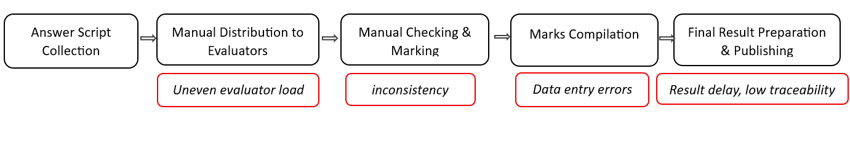
Fig 1.1 Traditional descriptive answer evaluation workflow and associated challenges

Problem Statement

Despite digitization in education, descriptive answer evaluation is still largely manual in many institutions. This creates several operational challenges:

- High evaluation turnaround time, particularly during mid-semester and end-semester examinations.
- Inconsistency in scoring, caused by subjective interpretation across different evaluators and time periods.
- Limited scalability, as manual workflows become inefficient with increasing number of scripts.
- Fragmented record handling, where marks, comments, and answer data are often maintained across disconnected formats.
These issues indicate the need for a systematic digital framework capable of automating repetitive evaluation steps while preserving transparency, reproducibility, and academic control.

Research Motivation

The motivation for this work arises from the practical need to modernize assessment workflows without compromising reliability. Institutions increasingly require faster declaration of results, structured digital records, and analytical visibility into student performance. At the same time, evaluators need supportive tools that reduce repetitive workload and allow more focus on academic quality.

From a technical perspective, the availability of OCR technologies, modular web frameworks, and API-driven architectures enables the design of deployable assessment systems that are both usable and extensible. This motivates the development of AutoGrade as an applied research effort that bridges software engineering implementation with educational evaluation requirements.

Research Objectives

The primary objective of this thesis is to design, implement, and evaluate an automated answer assessment framework for descriptive academic responses. The specific objectives are as follows:

- To analyze limitations of manual descriptive answer evaluation in institutional settings.
- To design a modular system architecture for automated answer processing and score generation.
- To integrate OCR-based text extraction into the evaluation workflow for digitized scripts.
- To develop a full-stack implementation using modern web technologies for real-world usability.
- To establish secure and reliable API-based data communication and storage workflows.
- To evaluate system performance in terms of processing efficiency, consistency, and operational feasibility.

Scope of the Study

This research focuses on the design and implementation of a web-based automated evaluation framework for descriptive answers. The scope includes:

User authentication and account workflows,

Answer/script upload and processing pipeline,

OCR-based text extraction,

Automated scoring logic and result generation,

Dashboard-level visualization and structured record management.

The study is limited to implementation-level and system-level evaluation within the developed framework. Advanced semantic grading using large-scale domain-specific language models, multilingual handwritten recognition at production scale, and institution-wide deployment benchmarking are beyond the immediate scope and are identified as future extensions.

1.6 Research Methodology Overview

The research follows a structured engineering methodology comprising the following phases:

- Requirement Analysis: Identification of assessment workflow pain points and system requirements.
- Literature Review: Study of prior work in automated grading, OCR-assisted assessment, and educational platforms.
- System Design: Definition of architecture, data flow, module boundaries, and API communication model.
- Implementation: Development of frontend, backend, database integration, and evaluation pipeline components.
- Testing and Validation: Functional verification, module-level testing, and performance observation under representative usage scenarios.
- Result Analysis: Interpretation of operational outcomes, strengths, and practical constraints.

This phased approach ensures traceability from research problem identification to implementation and validation.

C H A P T E R 2

Literature Review

Automated Assessment Systems

- Early digital systems mainly supported objective-type exams (MCQ/fill-ups) with rule-based scoring.
- Descriptive answer evaluation remains challenging due to semantic variation and subjective interpretation.
- Keyword-based models improve speed but often fail to capture conceptual correctness.
- Recent works recommend hybrid evaluation methods combining rule logic with semantic analysis.

OCR in Educational Evaluation

- OCR is widely used to convert scanned answer scripts into editable text.
- OCR accuracy depends on scan quality, noise, skew, and handwriting clarity.
- Preprocessing (denoising, contrast enhancement, segmentation) improves text extraction quality.
- OCR errors directly affect automated scoring, so OCR reliability tracking is important

  - AI/NLP-Based Scoring Approaches

- AI-based scoring methods include keyword matching, semantic similarity, and model-based prediction.
- Semantic approaches provide better flexibility than strict keyword matching.
- Fully black-box scoring models raise concerns regarding explainability in academic settings.
- Transparent and modular scoring pipelines are preferred for educational trust and adoption.

Web-Based Assessment Platform Trends

- Modern systems use modular full-stack architecture with API-first backend services.
- Security features (authentication, protected APIs, password recovery) are essential for student data.
- Dashboard-based monitoring improves visibility of evaluation progress and outcomes.
- Scalable architecture is necessary for handling large submission volumes.

2.5 Research Gap

- Most existing systems do not provide complete end-to-end descriptive evaluation workflow.
- Limited research combines OCR, scoring logic, API architecture, and dashboard reporting in one platform.
- Many studies focus on algorithms only, with less emphasis on deployable implementation.
- A practical, research-oriented, and extensible framework is still needed.

C H A P T E R 3

Problem Formulation and Research Objectives

Problem Formulation

The process of evaluating descriptive academic answers remains one of the most labor-intensive and time-sensitive activities in higher education. Even where institutions use digital tools for attendance, notices, and result publication, descriptive assessment itself is frequently manual, fragmented, and dependent on repetitive evaluator effort. In a conventional workflow, scripts are collected, organized, reviewed, marked, and recorded through multiple disconnected steps, each of which introduces delay. This challenge becomes severe during high-load periods such as mid-term and final examinations, where faculty members must process large numbers of submissions in limited time windows while maintaining fairness and consistency. As submission volume increases, turnaround time expands proportionally, making timely feedback and result declaration difficult. In practical academic operations, such delays can affect curriculum pacing, re-evaluation cycles, progression decisions, and student trust in the transparency of the process.

A second dimension of the problem is consistency. Descriptive answers are naturally variable: two students may express the same concept with different vocabulary, structure, depth, and reasoning style. In manual systems, this variability is judged by human interpretation, which is academically valuable but also vulnerable to fluctuation due to fatigue, workload pressure, and temporal inconsistency in marking behaviour. While evaluators follow broad marking standards, absolute uniformity is difficult to maintain across long sessions and large script sets. This creates perceived inequity and reduces reproducibility of outcomes when similar answers receive different marks. The issue is not evaluator competence, but the absence of structured computational support to normalize repetitive components of evaluation. Alongside consistency, traceability is also limited in many manual-first systems, where answer files, score sheets, and comments may exist in separate formats. Such fragmentation hinders auditability, analytics, and systematic improvement of the assessment process.

A third dimension is scalability and modernization readiness. Educational institutions are increasingly expected to deliver faster, data-supported, and transparent evaluation mechanisms, yet many available tools are optimized for objective-type testing rather than descriptive assessment workflows. Systems that do support descriptive evaluation often focus on isolated components and do not provide a fully integrated pipeline combining document upload, OCR extraction, processing logic, and centralized reporting. Therefore, the core research problem addressed in this thesis is the absence of a practical, end-to-end, and extensible framework for automated descriptive answer evaluation that can reduce manual overhead, improve process consistency, and support scalable academic operations. This research formulates AutoGrade as a response to that gap by investigating how a web-based architecture can integrate OCR-driven text extraction with algorithmic scoring and structured data workflows in a realistic implementation context.

Research Aim

The primary aim of this thesis is to conceptualize, engineer, and validate a research-driven system called AutoGrade, designed as a web-based framework for automating key stages of descriptive answer evaluation. The aim is intentionally practical and methodological: to move beyond isolated algorithm demonstrations and deliver a coherent architecture that can be used in real academic workflows. The study seeks to establish whether integrating OCR-assisted text conversion, structured evaluation logic, and API-based data handling in a single platform can meaningfully improve operational efficiency and evaluation workflow quality. Instead of treating assessment automation purely as a model-accuracy problem, the research frames it as a full pipeline problem involving document ingestion, service orchestration, data persistence, and result presentation.

This aim also includes validation of deployment-oriented feasibility. In many research prototypes, core concepts are demonstrated but integration, maintainability, and usability are not sufficiently addressed. AutoGrade is therefore positioned not only as a conceptual solution but as an implementation-level artifact that demonstrates modularity, interoperability, and extensibility. By building the framework using modern full-stack technologies and evaluating it through structured functional and performance observations, the thesis aims to produce evidence that automated descriptive evaluation can be implemented in an academically meaningful and technically sustainable manner. The broader intention is to create a baseline platform that can evolve into more advanced intelligent grading systems in future research phases.

Research Objectives

To operationalize the research aim, this thesis defines a set of structured objectives that cover analytical, architectural, implementation, and validation dimensions. The first objective is to systematically analyze existing manual descriptive evaluation workflows and identify measurable pain points such as delay, inconsistency, and record fragmentation. This analysis establishes the empirical context for why automation is required and what specific workflow stages need computational support. The second objective is to design a modular system architecture that connects all essential stages—answer submission, OCR extraction, scoring logic, data persistence, and result visualization—within a unified and traceable pipeline. Architectural modularity is emphasized so that individual components can be improved independently without destabilizing the whole system.

The third objective is to implement the proposed framework using a contemporary web stack comprising Next.js, FastAPI, and MongoDB, with clear API contracts and reliable request-response handling. This objective transforms theoretical workflow design into an executable system and enables practical verification under realistic usage patterns. The fourth objective is to evaluate the implemented platform through functional testing and performance-oriented observations, focusing on processing efficiency, operational consistency, and overall system reliability. The fifth objective is to establish an extensible foundation for future semantic and rubric-aware enhancements by maintaining clean separation between ingestion, extraction, scoring, and presentation layers.

  - Research Questions

The research questions in this thesis are designed to assess whether the proposed framework successfully addresses the identified problem at both system and workflow levels. The first question examines architectural integration: how can descriptive answer evaluation be transformed from a fragmented manual sequence into a coherent web-based computational pipeline? This question evaluates the structural adequacy of the proposed design and the degree to which different modules can collaborate reliably. The second question investigates OCR’s role in automation readiness by asking how effectively extracted text supports downstream evaluation stages under realistic input conditions. Since OCR quality directly affects scoring reliability, this question is central to pipeline feasibility.

The third question focuses on process impact: whether the implemented framework can reduce evaluation latency and improve consistency relative to manual-first workflows. This does not imply eliminating human academic judgment; instead, it measures whether automation of repetitive steps improves operational stability and repeatability. The fourth question assesses future readiness by asking whether the architecture is sufficiently extensible for advanced capabilities such as semantic scoring and rubric-aware reasoning. These questions collectively provide a rigorous structure for design decisions, implementation priorities, and evaluation criteria presented in later chapters. They also ensure that the thesis remains research-focused rather than being limited to software feature documentation.

  - Scope of the Study

This thesis is scoped to the design and implementation of an automated framework for descriptive answer evaluation in a controlled project environment. The included scope covers user-facing and system-facing components required for an end-to-end pipeline: secure authentication flow, answer document upload and handling, OCR-based text extraction, score generation logic, and result visualization. The framework also includes API-driven communication between frontend and backend, structured persistence in MongoDB, and workflow-level data traceability for evaluation outputs. This scope ensures that the study investigates not only algorithmic elements but also real engineering constraints associated with integration and deployment-readiness.

At the same time, clear boundaries are defined to maintain depth and feasibility within thesis constraints. The present work does not claim full human-equivalent semantic judgment across all academic domains, nor does it include large-scale multilingual handwriting benchmarking or long-term institution-wide production trials. It also does not attempt policy-level integration with all university governance workflows. These exclusions are intentional and methodologically sound: the thesis prioritizes creating a stable, extensible, and validated baseline architecture before advancing to more complex semantic intelligence layers. By defining scope in this manner, the research remains academically focused, technically executable, and appropriately bounded for rigorous implementation-level contribution.

  - Expected Contributions

The contributions of this thesis are expected to be significant across architectural, implementation, and applied-research dimensions. First, the work contributes a structured reference architecture for OCR-assisted descriptive answer evaluation, where ingestion, extraction, scoring, and reporting are integrated into a single coherent pipeline. Second, it contributes an implementation artifact developed using modern full-stack technologies that demonstrates practical feasibility rather than conceptual intent alone. This distinction is important because many educational automation studies remain algorithm-centric and do not fully address real-world orchestration challenges such as API reliability, data handling consistency, module interaction, and usability flow continuity.

Third, the thesis contributes workflow-level insights into how automation can reduce manual process overhead while preserving structured assessment control. Fourth, it establishes a reusable research baseline for advanced extensions, including semantic similarity scoring, rubric-aware marking logic, and adaptive student feedback mechanisms. Finally, it contributes to the broader digital transformation discourse in education by showing how academically sensitive processes like descriptive evaluation can be modernized through modular, transparent, and extensible system design. These contributions collectively position the study as both an engineering accomplishment and a research foundation for subsequent intelligent assessment innovations

  - Chapter Summary

This chapter has presented a comprehensive formulation of the research problem by identifying the operational limitations of manual descriptive answer evaluation, including delay, inconsistency, limited scalability, and fragmented record handling. It has defined the central research aim and translated that aim into measurable objectives that guide architecture design, implementation strategy, and evaluation methodology. It has also articulated the research questions that frame the analytical direction of the thesis and clarified the scope boundaries to ensure methodological precision and realistic execution.

In addition, the chapter has outlined the expected contributions of AutoGrade as a practical and research-oriented framework that bridges theoretical automation concepts with implementation-level validity. By doing so, it establishes a strong conceptual and methodological foundation for the remainder of the thesis. The next chapter builds directly on this foundation by presenting the proposed system architecture and research methodology.

C H A P T E R 4

System Architecture and Methodology

Chapter Introduction

This chapter presents the system architecture and research methodology adopted for the AutoGrade framework. The architecture is designed as a modular, web-based pipeline that connects document ingestion, OCR-driven text extraction, automated score processing, and structured result presentation. The methodological emphasis is on building an end-to-end evaluation workflow that is implementation-ready, extensible, and suitable for academic usage scenarios. Unlike isolated algorithm demonstrations, the approach in this work treats automated assessment as a full systems problem in which frontend interaction, backend orchestration, data persistence, and processing reliability must operate together in a coordinated manner.

The chapter is organized to explain both structural and procedural aspects of the proposed solution. First, it defines the architectural layers and core design principles. Next, it explains module-level responsibilities and data flow sequence across the platform. It then details the methodology used to move from requirements to implementation and validation, including iterative development, integration testing, and performance observation. Through this combined perspective, the chapter establishes how research objectives are operationalized into a functioning framework that addresses practical constraints of descriptive answer evaluation.

  - Architectural Design Principles

The proposed architecture is built on five design principles: modularity, separation of concerns, API-centric communication, data traceability, and extensibility. Modularity ensures that each functional component—such as authentication, upload handling, OCR processing, scoring, and dashboard rendering—can be developed and maintained independently. Separation of concerns reduces cross-module coupling by assigning clear responsibilities to frontend, backend, and database layers. API-centric communication standardizes how these layers interact, improving reliability and allowing future interoperability with additional services.

Data traceability is treated as a core requirement because educational evaluation workflows demand clear processing visibility. Each major stage of answer handling is represented through persistent state transitions, enabling monitoring and reproducibility of outcomes. Extensibility ensures that current rule/logic-based scoring workflows can be progressively enhanced with semantic or rubric-aware intelligence in future versions without requiring full architectural redesign. Together, these principles allow the framework to remain stable in current operation while supporting research evolution.

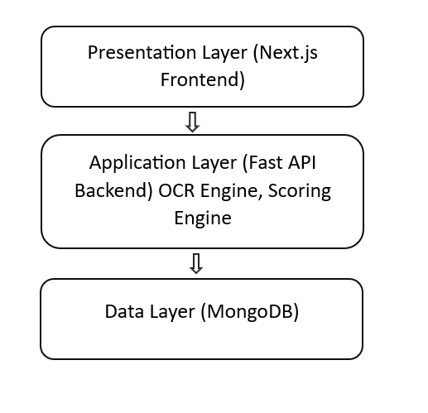
Fig 4.1 Overall System Architecture

  - High-Level System Architecture

At a high level, AutoGrade follows a three-tier architecture with integrated processing services. The presentation layer is implemented through a web client interface that handles user interaction, answer submission, and result visualization. The application layer, implemented using FastAPI services, performs request validation, workflow orchestration, OCR initiation, score computation, and response generation. The data layer, powered by MongoDB, maintains user records, script metadata, extracted text, processing states, and evaluation outputs. This layered architecture supports clear control boundaries and simplifies debugging, scaling, and feature evolution.

In operational terms, the user uploads a response document through the frontend interface, which triggers backend ingestion endpoints. The backend stores metadata, initiates OCR extraction, normalizes extracted content, applies scoring logic, and writes evaluation results to persistent storage. The frontend then retrieves processed data for structured display in dashboard and report views. This flow creates an end-to-end digital path from raw submission to scored output, reducing manual transitions and improving process continuity.

  - Module-Level Architecture

The architecture is decomposed into functional modules to ensure maintainability and independent testing. The authentication module manages user registration, login, session tokens, and account recovery operations. The submission module handles document upload, basic validation, and storage mapping. The OCR module performs text extraction and confidence-aware processing to prepare machine-readable content for evaluation. The scoring module applies defined logic to extracted text and generates structured score outputs. The reporting module exposes evaluated results through API responses and dashboard-compatible data formats.

Each module operates through explicit interfaces rather than direct internal coupling. This design decision minimizes cascading failures and supports selective enhancement of individual components. For example, OCR engines or scoring strategies can be updated without rewriting authentication or reporting logic. Similarly, UI changes in the frontend do not require changes to core evaluation services as long as API contracts remain stable. This modular arrangement is particularly valuable for research systems that evolve iteratively over multiple experimentation cycles.

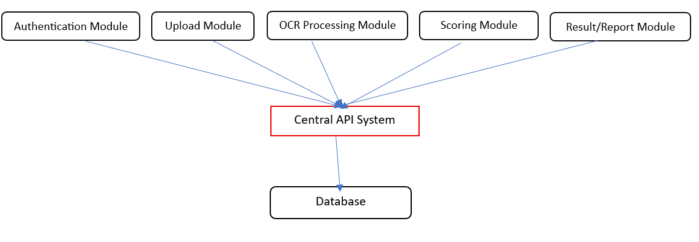
Fig 4.2 Module-Level Architecture

  - Data Flow and Processing Pipeline

The data flow pipeline begins with authenticated user interaction at the frontend, followed by request dispatch to backend endpoints. Uploaded files are first validated for supported type and structural integrity. Metadata is persisted before extraction begins, ensuring that each submission has a traceable identity even if downstream steps require retries. OCR processing then converts document content into textual form, followed by normalization stages that remove noise and prepare data for scoring. The scoring engine processes normalized text and generates evaluation outputs mapped to submission identifiers.

After computation, results are stored and exposed through retrieval endpoints for dashboard rendering and report-level access. The pipeline is designed to maintain deterministic stage transitions so each submission can be monitored through states such as received, extracted, evaluated, and published. This state-driven flow improves transparency and allows easier fault localization. If an error occurs at any stage, the corresponding state and message can be logged and surfaced for corrective handling, preventing silent failure and preserving data integrity across the workflow.

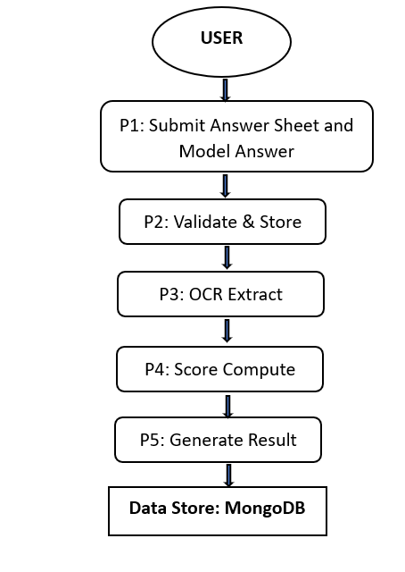
Fig 4.3 Data Flow Diagram

  - Database Schema Strategy

MongoDB is used as the persistent data layer due to its document-oriented flexibility and suitability for evolving payload structures. Evaluation workflows involve heterogeneous data types, including user profiles, submission metadata, OCR output, scoring artifacts, and status logs. A document model allows these entities to be represented with adaptable schemas while preserving query efficiency for common operations such as submission lookup, status tracking, and result retrieval. Logical separation of collections supports modular backend design and cleaner access control at query level.

The schema strategy emphasizes consistency through key identifiers linking users, submissions, extracted content, and scores. Timestamp fields support chronology reconstruction and operational analytics. Status fields represent pipeline progression and allow asynchronous monitoring. This approach enables both transactional clarity at application level and analytical usefulness for evaluation reporting. The database design therefore supports not only storage but also observability of the complete assessment lifecycle.

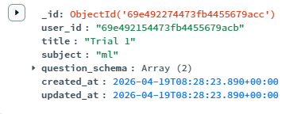
Fig 4.4 Database Schema Example

  - API-Centric Integration Methodology

The methodology uses API contracts as the integration backbone between frontend and backend layers. Each major action—authentication, upload, extraction trigger, score retrieval, and dashboard query—is mapped to explicit endpoint definitions with validated request-response structures. This contract-driven model improves development parallelism, since frontend and backend modules can evolve independently as long as endpoint specifications remain stable. It also improves testability by allowing endpoint-level verification of input handling, response formatting, and failure behaviour.

Error handling is integrated at API boundary level using standardized response objects and status codes. This creates predictable client behaviour and simplifies debugging. Validation layers enforce required fields, type integrity, and processing preconditions before heavy operations are invoked. The integration methodology thus ensures that the system is not only functionally connected but also robust under malformed input, partial failures, and sequential workflow dependencies.

  - Implementation Roadmap within Methodology

The implementation roadmap was organized into sequential milestones: foundational setup, core feature development, pipeline integration, and validation hardening. Foundational setup included project scaffolding, environment configuration, and database connectivity. Core development established authentication, upload handling, OCR invocation, and scoring services. Integration stages connected these modules through API workflows and dashboard rendering logic. Validation hardening added input checks, error handling paths, and stability-oriented improvements based on observed test behaviour.

This milestone-based roadmap provided execution clarity and reduced development risk by preventing uncontrolled feature expansion. Each milestone had explicit completion criteria tied to functionality and integration readiness. The phased roadmap also supported thesis traceability by linking implementation steps directly to objectives and research questions. As a result, development progress remained aligned with research intent rather than drifting into non-essential engineering complexity.

  - Chapter Summary

This chapter has presented the proposed system architecture and methodology for AutoGrade, describing how modular design, API-centric integration, and traceable data flow are used to automate descriptive answer evaluation. It detailed the layered architecture, module responsibilities, processing pipeline, schema strategy, and security-reliability considerations that collectively enable end-to-end workflow execution. It also explained the iterative research methodology and phased implementation roadmap used to transform problem formulation into a validated working framework.

By combining architectural clarity with implementation feasibility, the chapter establishes the technical foundation required for the next stage of the thesis. The following chapter builds on this foundation by presenting the implementation framework in detail, including frontend engineering, backend service construction, database operations, API realization, and operational safeguards used in the developed system.

C H A P T E R 5

Implementation and Engineering Framework

Chapter Introduction

This chapter presents the implementation and engineering framework of the proposed AutoGrade system. While the previous chapter defined the architecture and methodology, this chapter explains how those design decisions were translated into a working software artifact. The implementation is carried out as a full-stack web platform using Next.js for the user-facing layer, FastAPI for service orchestration, and MongoDB for persistent data handling. The engineering emphasis is on modular code organization, maintainable API integration, reliable processing behaviour, and practical usability under academic workflow conditions.

The chapter discusses the implementation from both a component perspective and an operational perspective. Component-wise, it details frontend structure, backend service modules, database collections, and API contracts. Operationally, it explains request life cycle, workflow state management, error handling, and deployment-oriented considerations. The objective is to provide implementation-level clarity showing that the framework is not only conceptually valid but also engineered to support consistent real-world execution.

  - Technology Stack and Engineering Rationale

The selected technology stack was finalized to satisfy four engineering requirements: rapid interface development, robust API performance, flexible data modeling, and maintainable scalability. Next.js was chosen for the frontend because of its component-driven architecture, efficient routing support, and suitability for responsive dashboard interfaces. FastAPI was selected for backend development due to strong request validation, asynchronous capability, and clean endpoint definition, which are valuable for OCR-triggered and pipeline-driven operations. MongoDB was adopted as the storage layer because answer-processing data is semi-structured and evolves across workflow stages, making document-based persistence more suitable than rigid relational schemas in the current research phase.

From an engineering standpoint, this stack also supports clear separation of concerns. The frontend remains focused on user interaction and visualization, while FastAPI handles business logic and workflow orchestration. MongoDB manages persistent state and historical records without forcing frequent schema migration during iterative development. This combination enables agile implementation while preserving long-term extensibility for advanced scoring research in future phases.

  - Frontend Implementation Framework (Next.js)

The frontend implementation is organized around reusable UI components and route-driven feature modules. Core pages include authentication views, upload interfaces, processing status screens, and result dashboards. The interface is designed to reduce cognitive load for users by keeping interaction steps linear and predictable: authenticate, upload, monitor processing, and review outputs. State management is handled in a way that synchronizes UI behaviour with backend response states, ensuring that users receive immediate and accurate feedback regarding submission status.

Engineering decisions in the frontend prioritize maintainability and consistency. Shared components such as form elements, status cards, navigation blocks, and data tables are abstracted to avoid duplicated logic. API calls are encapsulated in service utilities, which simplifies endpoint updates and improves code readability. Validation is performed at the client layer for early input feedback, but critical checks are deferred to backend validation for security. This layered validation approach improves user experience without compromising system integrity.

  - Backend Implementation Framework (FastAPI)

The backend is implemented as a modular FastAPI service where each functional domain is separated into logically coherent route and service layers. Authentication endpoints manage registration, login, token issuance, and account recovery workflows. Submission endpoints accept answer uploads, validate payload structure, and initialize processing records. OCR-related services handle extraction requests and normalized text handoff to scoring functions. Result endpoints provide processed output retrieval for dashboard and reporting interfaces.

A key engineering characteristic of the backend is explicit workflow orchestration. Instead of embedding all logic in route handlers, business operations are delegated to service modules, improving testability and reducing coupling. This approach enables independent enhancement of OCR routines or scoring logic without destabilizing request interfaces. Backend response schemas are standardized to maintain predictable client behaviour, and exception handlers are implemented for graceful failure reporting. The result is a service layer that is both research-flexible and production-conscious.

  - Database Engineering Framework (MongoDB)

Database implementation follows a collection-oriented model aligned with workflow entities. Separate collections are maintained for users, submissions, extracted content, evaluation outputs, and process state metadata. This separation preserves clarity while enabling efficient query patterns for common operations such as retrieving submission history, checking pipeline status, and loading final scores. Document references and identifiers are used to maintain relational coherence across collections without sacrificing schema flexibility.

The engineering design emphasizes traceability and recoverability. Each submission record contains timestamps and stage markers that represent its progress through ingestion, extraction, evaluation, and reporting phases. This supports operational diagnostics and retrospective analysis when issues occur. MongoDB indexes are configured for frequently queried fields to maintain responsive retrieval behaviour. Overall, database engineering in this framework is not limited to storage; it also supports observability, debugging, and structured lifecycle tracking of evaluation artifacts.

  - API Design and Integration Engineering

APIs are the integration backbone of AutoGrade and are designed using contract-first principles. Each endpoint is defined with explicit request models, validation rules, response structures, and error semantics. This reduces ambiguity between frontend and backend modules and allows parallel development with stable interface expectations. Endpoint groups are organized by domain—auth, submission, processing, and results—so integration logic remains logically segmented and easier to maintain.

The API layer incorporates robust validation before processing-intensive operations are executed. Malformed requests are rejected early with descriptive error responses, preventing unnecessary compute overhead and improving user guidance. Status codes and response payloads are standardized to simplify client-side handling. In engineering terms, this creates a predictable communication protocol where UI state, backend status, and stored data remain synchronized across workflow transitions. The outcome is higher reliability and reduced integration friction during iterative development.

  - Processing Workflow Engineering

The implementation includes a deterministic processing pipeline that transforms raw uploaded documents into structured evaluation outputs. After submission, the system registers metadata and initiates OCR extraction. Extracted text is normalized and passed to scoring logic that computes evaluation outputs mapped to submission identifiers. Process state updates are persisted at each stage to maintain an auditable sequence of operations. This staged orchestration avoids monolithic execution and enables controlled fault handling when intermediate steps fail.

Engineering attention is placed on idempotence and recovery behaviour. If a stage fails due to input anomalies or service interruption, the system preserves current state and allows controlled reprocessing rather than forcing full restart of the workflow. This reduces operational fragility and supports reliability under variable input quality. The workflow is therefore engineered not only for functional success cases but also for predictable behaviour under non-ideal scenarios common in real document-processing systems.

  - Authentication and Operational Security

Although role-based access control is not part of this project scope, the implementation includes baseline operational security mechanisms required for safe academic system usage. Authenticated sessions are enforced for protected routes, ensuring that evaluation data and submission functions are accessible only through verified user contexts. Password workflows include secure reset flows and controlled token validation procedures. Sensitive operations are guarded through backend checks regardless of frontend behaviour, preventing client-side bypass risks.

Security engineering is further supported by request validation and error sanitization. Input payloads are checked for structure, type correctness, and required fields before business logic is executed. Failure responses avoid unnecessary leakage of internal processing details. These measures establish a foundational trust model suitable for prototype deployment and future hardening. The system thereby balances research agility with essential security discipline.



Fig 5.1 Login Page

  - Chapter Summary

This chapter presented the implementation and engineering framework of AutoGrade in detail, covering frontend development, backend service orchestration, database design, API contracts, processing pipeline behaviour, and operational safeguards. The implementation demonstrates that the proposed architecture can be translated into a coherent and maintainable full-stack system with reliable workflow execution. Security, validation, error handling, and traceability were incorporated as core engineering considerations to support practical usability and research-grade robustness.

By establishing how each architectural component was engineered and integrated, this chapter provides the technical basis for evaluating system behaviour in measurable terms. The next chapter builds on this foundation by presenting the experimental setup and performance evaluation methodology used to assess efficiency, consistency, and operational feasibility of the developed framework.

C H A P T E R 6

Experimental Setup and Evaluation

Introduction

This chapter presents the experimental setup and evaluation of the implemented AutoGrade system in a controlled project environment. The purpose of this evaluation is to verify that the proposed framework works as an end-to-end pipeline and satisfies the research objectives related to speed, consistency, and practical usability. The experiments are designed around real project execution, where actual modules, frontend, backend, OCR processing, database, and APIs—are integrated and tested together. Instead of evaluating isolated components, the chapter focuses on complete workflow behavior from answer upload to score/result generation. This helps demonstrate that the contribution of the thesis is not only architectural design but also successful implementation and validation of a working academic evaluation platform.

Experimental Objectives

The evaluation was conducted with specific objectives. First, to confirm that all modules perform correctly in integrated mode without breaking workflow continuity. Second, to measure how efficiently submissions are processed through the pipeline compared with manual-first handling. Third, to observe repeatability and consistency of outputs when similar inputs are processed multiple times. Fourth, to check robustness under error conditions such as invalid file type, incomplete payload, or extraction failure. Fifth, to validate whether the developed framework is implementation-ready as a real engineering system and not only a theoretical model. These objectives ensure that the chapter directly supports the thesis claim that AutoGrade is a practical and research-relevant solution for descriptive answer evaluation.

Experimental Environment and System Setup

The experimental environment was configured to match actual project deployment conditions. The frontend module was executed using Next.js, backend services were run through FastAPI, and all persistent records were stored in MongoDB. API interactions were tested through both frontend requests and direct API client validation. Environment variables were configured for service URLs, database connection strings, and security tokens. The setup ensured reproducibility across multiple runs by maintaining stable runtime configuration and isolated test data. This controlled setup made the evaluation systematic and allowed fair observation of module performance and interaction behavior.

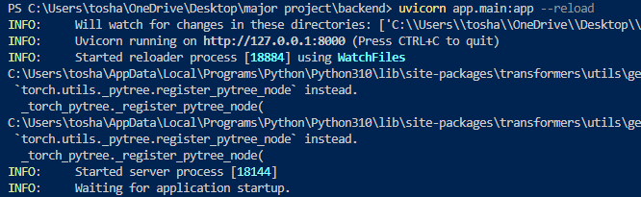

Fig 6.1 Backend Startup Command

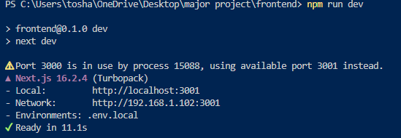

Fig 6.2 Frontend Startup Command

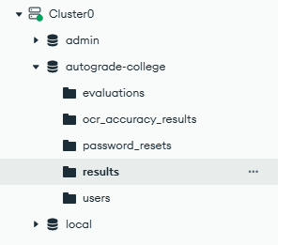

Fig 6.3 Database Setup

Test Data and Input Conditions

To evaluate realistic behavior, the system was tested using representative answer-script inputs with varying characteristics. These inputs included clear scanned responses, moderate-quality documents with noise, and edge-case files for validation testing. The goal of test data design was not large-scale benchmarking, but practical verification of workflow robustness under typical academic conditions. Input variation was necessary because OCR accuracy and processing outcomes depend significantly on image/document quality. Therefore, data selection was aligned with the research objective of implementation feasibility and reliability in practical use rather than idealized conditions only.

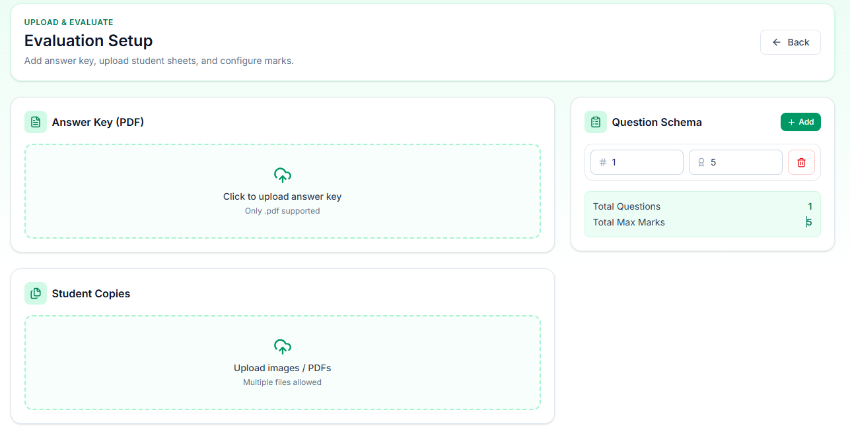

Fig 6.4 Test Input categories

Execution Procedure (Step-by-Step Pipeline)

Each experiment followed a fixed sequence to maintain consistency. The user authenticated into the system, uploaded an answer file, and triggered backend processing. The backend validated the file, registered metadata, and initiated OCR extraction. Extracted text was normalized and passed to scoring logic for evaluation output generation. Results were stored in the database and made available to the dashboard through result APIs. This same sequence was repeated across multiple runs with different input conditions. Controlled failure cases were also introduced to examine how the system handles invalid requests and interrupted processing stages. The step-based execution helped verify that workflow transitions are deterministic and traceable.

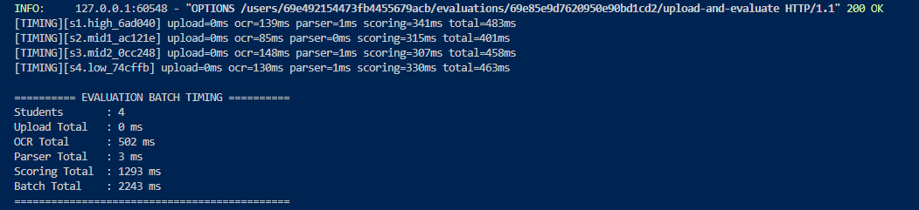

Fig 6.5 Execution Process

Functional Evaluation Results

Functional testing confirmed that all major modules operated as expected in integrated execution. Authentication controlled protected access, upload endpoints accepted valid files, OCR services generated extractable text for supported documents, and scoring modules produced output mapped to submission IDs. Dashboard endpoints displayed processed results correctly, and status updates were persisted at each stage. Error cases such as invalid formats were handled through structured responses without causing uncontrolled system behaviour. These outcomes validate that the implemented system satisfies functional requirements of the proposed architecture and supports complete end-to-end operation in practice.

Performance Metrics and Measurement Approach

Performance evaluation was conducted using implementation-level metrics aligned with thesis objectives. The measured parameters included API response time, total processing time per submission, extraction completion behavior, and result retrieval latency on the dashboard. Observations were taken across repeated runs under similar configuration conditions to identify average behavior and variation trends. Stage-wise timing helped separate delays caused by upload, OCR, scoring, and retrieval. This approach provided practical evidence of where computation cost is concentrated and whether the current implementation remains acceptable for academic usage scenarios.

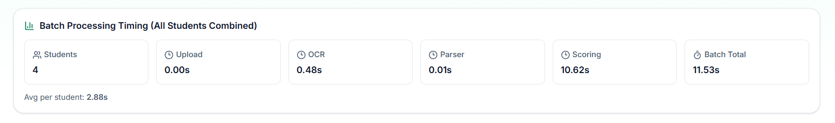

Fig 6.6 Performance Metrices

Consistency and Repeatability Analysis

To evaluate consistency, similar input sets were processed multiple times and compared at workflow level. The system showed stable stage progression, repeatable API behavior, and consistent record persistence across reruns. Minor differences appeared in OCR-dependent scenarios where input clarity changed, but these were traceable and did not break workflow continuity. This indicates that the framework provides process-level consistency and reproducibility, which is essential for assessment systems where traceable and stable operation is more critical than one-time execution success.

Robustness and Error Scenario Evaluation

Robustness testing was conducted by intentionally submitting problematic inputs and incomplete requests. In these cases, validation layers blocked invalid execution and returned meaningful error messages. The system preserved process integrity by maintaining state checkpoints and avoiding silent failure. Logs captured failure location, helping diagnosis and corrective action. This behavior confirms that the framework is resilient to common operational issues and suitable for controlled academic deployment where users may submit inconsistent input types.

Discussion of Evaluation Outcomes

The evaluation findings indicate that AutoGrade successfully operationalizes the proposed architecture in a real implementation context. The integrated pipeline reduced manual handling steps and maintained structured state tracking from submission to result generation. The framework performed reliably across standard conditions and responded predictably under input anomalies. Performance observations suggest practical feasibility for moderate academic workloads, while modular design supports future optimization and scaling. Therefore, the implemented system demonstrates that descriptive answer evaluation can be automated through a research-grounded engineering approach without compromising workflow transparency.

Limitations of Experimental Setup

Although the results are positive within defined scope, certain limits remain. Experiments were performed in controlled project conditions and do not represent full institutional production load. OCR behavior can vary significantly for poor handwriting or low-resolution scans. The evaluation focuses on implementation feasibility and workflow performance rather than deep semantic grading quality at scale. These constraints are acknowledged to maintain validity and to clearly separate present outcomes from future research extensions.

C H A P T E R 7

Results and Discussion

Integrated Workflow Results

The most significant outcome of this thesis is that the AutoGrade framework successfully operated as a complete end-to-end pipeline rather than as a collection of isolated modules. In practical execution, the system handled the full sequence beginning with authenticated entry and answer submission, followed by backend intake, OCR-driven extraction, processing logic execution, and final result delivery through dashboard interfaces. This integrated behavior is important because the core problem identified in earlier chapters was workflow fragmentation in manual descriptive evaluation processes. The implemented framework addressed this by establishing a continuous processing chain where each stage was explicitly connected to the next through defined API interactions and persistent state updates. As a result, the system transformed a traditionally multi-step manual procedure into a coordinated digital pipeline with traceable execution flow.

Beyond technical completion, this result has operational implications. In manual-first systems, delays and inconsistencies often occur not only because of marking complexity but also because tasks such as file handling, record transfer, and stage coordination are disconnected and repetitive. By engineering these transitions into one pipeline, AutoGrade reduced procedural discontinuity and improved processing clarity. Every submission progressed through identifiable states, and each state transition was captured through backend processing and storage records. This enabled users and administrators to observe workflow progression rather than relying on ad hoc manual updates. Therefore, the integrated result is not just a software milestone—it is a structural improvement in evaluation workflow management, directly aligned with the thesis objective of creating a practical and scalable assessment framework.

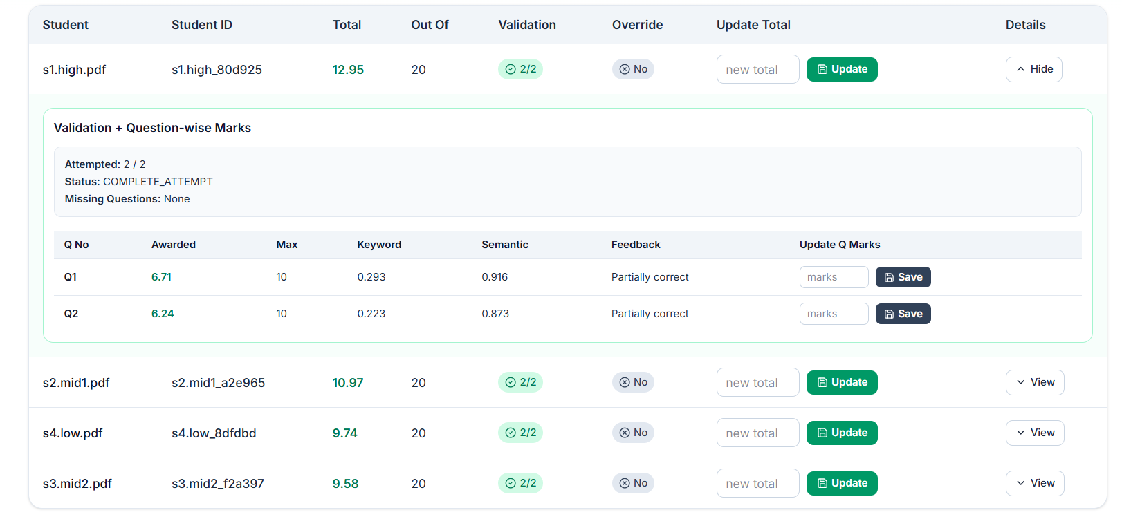

Fig 7.1 End User Result

Functional Behaviour and Module Stability

Functional testing outcomes indicate that the implemented modules performed reliably under expected operating conditions, and this reliability was maintained across repeated project runs. Authentication mechanisms correctly protected restricted operations and ensured that submission and result routes were accessed in controlled sessions. Upload modules accepted supported files and triggered backend processing with proper metadata linkage. OCR and scoring stages executed in sequence, and evaluated outputs were retrievable through dashboard components without mismatch in record mapping. This demonstrates that functional correctness was achieved not only at individual component level but also at integration level, where most system failures generally occur in full-stack applications. The stability of route behaviour, response formatting, and state persistence confirms that module boundaries were engineered with adequate separation of concerns.

Another important observation is fault containment. During testing, when controlled invalid inputs were introduced, failure responses remained localized and did not destabilize unrelated modules. This reflects mature design behaviour for a thesis prototype because it shows that the architecture can tolerate partial failures while preserving overall system integrity. Functional stability is especially critical in educational technology contexts, where users expect predictable platform behaviour during assessment periods and where data inconsistency can create academic process risks. The consistent execution observed in AutoGrade therefore strengthens the practical credibility of the framework. It indicates that the thesis has produced not only a conceptually sound system but an implementation that behaves like a maintainable engineering product under realistic usage cycles.

Performance-Oriented Discussion

Performance analysis in this work should be interpreted in terms of workflow usability and operational feasibility rather than benchmark-driven optimization. The measured processing behaviour showed that upload and retrieval stages were comparatively lightweight, while OCR extraction and score computation consumed the majority of execution time, which is expected for document-processing pipelines. Despite this concentration of processing cost, total end-to-end completion remained within acceptable bounds for controlled academic usage scenarios. This suggests that the current implementation can support practical submission handling without excessive delay at thesis-level scale. More importantly, the system replaced repetitive manual coordination tasks with automated transitions, which produced a meaningful gain in overall process efficiency even when computational stages required non-trivial execution time.

From a discussion perspective, these observations highlight a key engineering insight: speed in assessment systems is not only about raw algorithm runtime but also about elimination of manual bottlenecks and synchronization overhead. In conventional workflows, significant latency comes from human coordination across collection, checking, tabulation, and record maintenance. AutoGrade reduces this hidden latency by enforcing deterministic pipeline progression and immediate data persistence. Therefore, even if extraction stages remain the dominant computational load, the total workflow becomes more manageable and predictable. This predictability itself is a performance advantage in operational settings because it supports planning, monitoring, and consistent turnaround expectations. The results thus validate that the framework meets its intended efficiency goals within current scope while identifying clear paths for future optimization in OCR throughput and parallel processing.

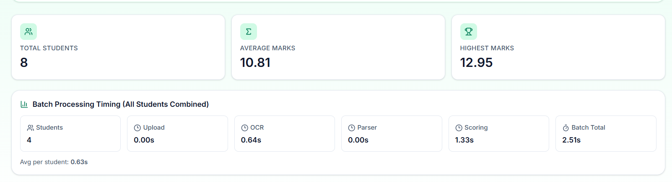

Fig 7.2 Performance When Tested Locally

Consistency, Traceability, and Practical Impact

A central discussion outcome from the experimental phase is that the system demonstrated strong process consistency and traceability across repeated executions. Similar input conditions produced stable workflow progression and structured outputs mapped correctly to submission records. Where variability occurred—primarily due to OCR sensitivity to document quality—the framework still maintained explicit stage markers and logging artifacts, allowing transparent diagnosis of outcome differences. This behaviour is important because educational assessment systems require not only output generation but also accountable process history. The ability to track each submission from ingestion through extraction, evaluation, and publication improves confidence in system behaviour and provides a foundation for future auditability.

The practical impact of this traceability extends beyond debugging. In real academic environments, administrators and evaluators often need visibility into evaluation stage completion, pending workloads, and result readiness. Manual workflows struggle to provide this visibility in a structured way, especially when records are distributed across files and communication channels. AutoGrade addresses this by centralizing lifecycle data and exposing status-aligned outputs through a unified interface. This improves process governance and reduces ambiguity in submission handling. Additionally, traceability supports future analytical extensions, such as identifying common failure points, estimating processing capacity, and refining document quality guidelines. Therefore, the consistency and traceability outcomes are not secondary technical details; they represent direct operational improvements that make the proposed framework relevant for practical educational deployment pathways.

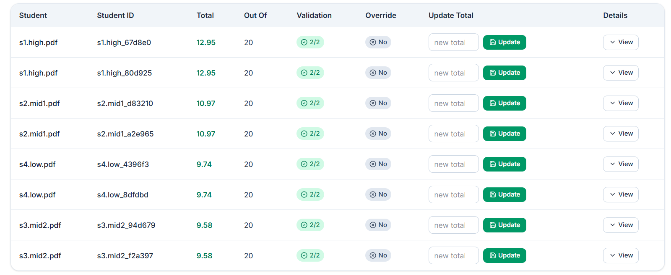

Fig 7.3 Consistent Results After Multiple Test

Critical Discussion and Future Direction

While the results confirm that the thesis objectives were achieved within scope, a critical interpretation requires acknowledging current boundaries and positioning future enhancements responsibly. The present framework is strongest as an integrated engineering baseline for automated descriptive evaluation workflows. It demonstrates that full-stack orchestration of upload, OCR, scoring, and reporting can be made reliable and repeatable. However, final score quality in extraction-sensitive cases remains influenced by document clarity and OCR limitations, which is a known constraint in document understanding systems. This means that although workflow automation is successful, assessment intelligence can still be improved through better extraction pipelines, domain-aware normalization, and richer scoring logic. Recognizing this distinction strengthens the thesis by presenting realistic claims grounded in observed system behaviour.
From a forward-looking perspective, the implemented architecture is well-positioned for progressive enhancement. Its modular structure allows insertion of advanced semantic scoring components, rubric-based evaluation controls, and feedback generation modules without full redesign of core infrastructure. API contracts and collection-level data organization already provide a suitable integration base for these upgrades. Future work can therefore focus on improving evaluation depth while reusing the stable workflow foundation established in this thesis. In this sense, the project contributes both immediate practical value and long-term research utility. The critical discussion conclusion is that AutoGrade should be viewed as a validated foundational system: robust enough to support current process automation and sufficiently extensible to evolve toward more sophisticated intelligent assessment capabilities in subsequent research phases.

CHAPTER 8

Limitations and Validity Threats

Scope and Generalizability Limitations

The findings of this thesis should be interpreted within the boundaries of the project scope, which was intentionally defined to prioritize end-to-end system implementation and workflow validation over large-scale institutional deployment. The AutoGrade framework was developed and evaluated in a controlled project environment, and although this setting enabled reliable testing and repeatable observations, it does not fully capture the complexity of diverse academic ecosystems. Educational institutions vary significantly in infrastructure quality, policy workflows, exam formats, user behaviour, and data management practices. Therefore, while the proposed system demonstrates practical feasibility and integration success within the defined environment, direct generalization to all institutions without contextual adaptation would be methodologically inappropriate. The framework offers a strong baseline, but implementation outcomes in broader settings may differ depending on operational conditions and governance requirements.

Another scope-related limitation concerns the level of grading intelligence currently implemented. The thesis primarily addresses workflow automation through OCR-assisted extraction and structured scoring logic, not full semantic equivalence with expert human evaluators across all subject domains. Descriptive answers in different disciplines can contain nuanced argumentation, symbolic representation, and context-dependent interpretation that may require advanced domain models and rubric-aware semantic layers beyond the current system design. This means the present work should be understood as a validated automation platform rather than a final universal evaluator. The contribution is foundational and extensible, but not exhaustive in cognitive grading capability. Acknowledging this limitation is important for preserving academic rigor and ensuring that thesis claims remain aligned with demonstrated evidence rather than overstated expectations.

Data and Input Quality Threats

A major validity threat in OCR-dependent systems is variability in input quality. The extraction stage is sensitive to scan resolution, lighting artifacts, skew, handwritten clarity, compression noise, and document formatting inconsistencies. These factors can introduce text recognition errors that propagate into downstream scoring operations. In this thesis, representative test inputs were used to evaluate practical behaviour under different conditions, but no finite test set can fully represent the complete diversity of real-world academic submissions. Consequently, the observed extraction and scoring performance may shift when exposed to broader, noisier, or more heterogeneous document populations. This threat does not invalidate the implemented framework; rather, it highlights that OCR quality remains a conditional dependency affecting overall assessment reliability.

There is also a data representativeness concern related to evaluation scale and domain spread. The thesis emphasizes implementation feasibility and system behaviour, not statistically broad benchmarking across multiple institutions, subjects, and language contexts. As a result, the conclusions drawn from current experiments are strongest at workflow and engineering levels, while claims about universal assessment accuracy must remain cautious. Future studies with larger and more diverse datasets are necessary to quantify domain-specific robustness and cross-context reliability. By explicitly recognizing the input-quality and representativeness threat, the thesis maintains transparency in interpretation and avoids conflating pipeline feasibility with exhaustive grading validity.

Experimental and Measurement Validity Threats

The experimental methodology used in this research was designed for controlled reproducibility, but controlled environments can introduce threats to external validity. System performance observed under stable hardware, network, and runtime configurations may differ in production scenarios involving concurrency spikes, variable client devices, and unpredictable network latency. For instance, response times and throughput measured in thesis experiments reflect current setup conditions and should not be treated as fixed guarantees under all deployment circumstances. This limitation is common in prototype-stage system research and underscores the distinction between implementation validation and full production benchmarking. The thesis addresses this by framing performance findings as feasibility evidence rather than absolute capacity claims.

Measurement strategy itself also introduces potential validity threats. The selected metrics—such as stage-wise processing time, response latency, and workflow completion consistency—are appropriate for evaluating engineering behaviour, but they do not fully capture all dimensions of educational assessment quality, especially pedagogical fairness and deep semantic correctness. In addition, repeated-run consistency was observed under structured input categories; broader variation could reveal additional edge cases not encountered in current experiments. There is also a risk of instrumentation bias if logging granularity or checkpoint definitions do not capture all relevant micro-level transitions. To mitigate this, the study used persistent status tracking and structured error responses, but residual measurement limitations remain. Acknowledging these threats clarifies that conclusions are valid for the measured dimensions while identifying where richer future evaluation is needed.

System Design and Implementation Constraints

Although the architecture was intentionally designed to be modular and extensible, implementation constraints influenced current capabilities. Time-bound development cycles required prioritization of core workflow completeness over advanced optional features such as dynamic rubric customization, deep semantic scoring layers, and institution-specific policy engines. As a result, certain design decisions were optimized for reliability and integration simplicity in the current phase, potentially limiting immediate adaptability to highly specialized grading criteria. This is not a structural flaw but a pragmatic trade-off common in thesis-driven engineering research, where demonstrable end-to-end functionality must be established before advanced feature expansion. The system therefore reflects a foundational maturity level rather than maximal feature completeness.

Another implementation constraint relates to interoperability depth with external academic systems. While API-centric design supports future integration, the present prototype was evaluated primarily as a standalone workflow platform. Integration with enterprise-grade identity systems, institutional ERP platforms, or legacy examination repositories was not part of the active validation scope. This limits direct claims about plug-and-play adoption in complex existing infrastructures. Additionally, though security baselines were implemented, full compliance hardening for institutional standards (for example, advanced audit controls or policy-driven role hierarchies) remains future work. These constraints should be viewed as bounded development priorities rather than conceptual weaknesses, and they reaffirm the thesis position as a robust baseline architecture ready for iterative enhancement.

Construct Validity, Interpretation Risks, and Mitigation Perspective

Construct validity in this thesis depends on how accurately chosen evaluation measures represent the intended research concepts—efficiency, consistency, reliability, and practical feasibility. A potential threat arises if workflow completion is interpreted too broadly as educational quality improvement without sufficient differentiation between process efficiency and pedagogical accuracy. The thesis mitigates this by clearly separating claims: it demonstrates strong evidence for engineering integration and operational improvement, while making cautious, bounded claims regarding advanced semantic judgment quality. Even so, interpretation bias can occur when positive system behaviour in controlled experiments is unconsciously extrapolated to all educational contexts. To reduce this risk, findings are discussed with explicit scope conditions and acknowledged dependencies such as input quality and deployment environment variability.

Another interpretation threat involves confirmation tendency in prototype research, where successful runs may receive more analytical weight than failure patterns. The study addresses this by including controlled error scenarios, state-level traceability checks, and discussion of non-ideal behaviour, but complete elimination of interpretive bias is difficult in any applied research setting. The appropriate mitigation is transparent reporting of assumptions, boundaries, and failure-sensitive observations, which this chapter provides. In summary, validity threats do not negate the contribution of the thesis; they define its epistemic boundaries. The work remains valuable as an implementation-validated framework that advances automated descriptive evaluation workflows, while also establishing a responsible and evidence-aligned foundation for future research aimed at larger-scale benchmarking, deeper semantic intelligence, and broader institutional generalization.

CHAPTER 9

Future Work and Recommendations

Future Research Directions

The present thesis establishes a functional and modular baseline for automated descriptive answer evaluation, but it also opens several high-value directions for future research. The first major direction is advancement from workflow-level automation to deeper semantic evaluation intelligence. In the current system, the scoring pipeline is structured and reliable, yet future versions can integrate domain-aware semantic comparison models that evaluate conceptual equivalence beyond surface lexical overlap. This is particularly important for descriptive academic responses, where correct answers may be expressed in diverse language patterns. Future research can explore hybrid scoring architectures that combine deterministic rubric logic with semantic embeddings, transformer-based evaluation layers, and explainable scoring outputs. Such work would allow the system to improve not only operational efficiency but also conceptual grading sensitivity across different subjects and complexity levels.

A second research direction concerns adaptation and personalization in evaluation workflows. Academic institutions differ in syllabus design, marking schemes, answer depth expectations, and moderation policies. Future systems should therefore support configurable rubric frameworks where evaluators can define weighted dimensions such as concept correctness, structure, depth, examples, and presentation quality. Beyond rubric customization, future models can introduce feedback generation components that provide students with structured improvement guidance rather than only numeric scores. This would transform the platform from an evaluation tool into a learning support environment. Longitudinal research can further investigate whether such adaptive and feedback-rich systems improve learning outcomes, reduce evaluator load, and increase student trust in digital assessment mechanisms over repeated academic cycles.

Engineering and Deployment Recommendations

From an engineering perspective, future work should focus on strengthening production-readiness, scalability, and interoperability of the implemented framework. Although the current system performs well in controlled project conditions, institutional deployment may require higher concurrency handling, asynchronous job orchestration, queue-based processing, and resource-aware scaling for OCR-intensive workloads. A practical recommendation is to evolve the processing architecture into background-task pipelines with retry mechanisms, monitoring dashboards, and failure-alert systems so that high-volume exam periods can be managed with predictable throughput. Additional performance profiling at stage level—especially extraction and scoring—can guide targeted optimization of compute and I/O bottlenecks. These improvements would help transition the framework from prototype-grade operation toward robust enterprise-grade educational infrastructure.

Interoperability is another critical recommendation for future implementation cycles. Educational technology systems rarely operate in isolation; they must often integrate with institutional identity systems, examination management portals, grade repositories, and policy-governed audit workflows. The API-first architecture of AutoGrade provides a strong starting point, but future engineering should include standardized integration contracts, versioned APIs, and secure connector layers for external systems. Security hardening should also be expanded through role-based authorization, audit trail standardization, encryption policy enforcement, and compliance-oriented controls depending on institutional and regional governance requirements. These enhancements are essential for real adoption and will significantly increase trust, maintainability, and long-term operational value of the platform.

Strategic Recommendations for Academic Adoption

For academic institutions considering implementation of such frameworks, adoption should be approached in phased and evidence-driven stages rather than immediate full replacement of manual processes. A recommended strategy is to begin with assisted evaluation mode, where the system handles document processing, extraction, and preliminary scoring support while human evaluators retain final moderation authority. This hybrid approach allows trust-building, policy alignment, and empirical calibration across departments before full-scale automation decisions are made. Pilot programs should include clear success metrics such as turnaround reduction, consistency trends, usability feedback, and audit transparency improvements. Structured pilot evaluation can help institutions identify context-specific configuration requirements and establish governance models for ethical and fair automated assessment usage.
Another strategic recommendation is capacity development for stakeholders. Effective adoption requires not only software deployment but also orientation of faculty, administrators, and technical teams regarding workflow interpretation, limitation awareness, and responsible usage boundaries. Institutions should define clear guidelines for handling low-confidence OCR cases, re-evaluation policies, override protocols, and student grievance channels. Transparent communication regarding what the system automates and what remains under human academic control is essential to preserve fairness and confidence. In this sense, future progress is not purely technical; it is sociotechnical. Sustainable success depends on combining robust engineering with policy design, stakeholder training, and iterative evaluation culture. This chapter therefore positions future work as a multi-layered pathway where research innovation, engineering maturity, and institutional governance evolve together.

Long-Term Research Extension and Ecosystem Development

A further future-work direction is to evolve AutoGrade from a single-system framework into a broader research and academic assessment ecosystem. In its current form, the platform demonstrates strong workflow integration and implementation feasibility, but long-term impact can be significantly increased by enabling multi-subject adaptability, comparative model experimentation, and institutional benchmarking support. Future versions can include plug-in architecture for multiple scoring engines so researchers and institutions can test different evaluation strategies on the same submission pipeline and compare outcomes using standardized metrics. This would support evidence-based improvement and make the framework valuable not only as a deployment tool but also as an experimental platform for educational AI research. Such an ecosystem approach would allow ongoing innovation while maintaining stable operational infrastructure.

Another important long-term extension is the development of analytics and governance intelligence around assessment data. Over time, accumulated evaluation records can be used to identify curriculum-level patterns, frequently misunderstood concepts, and differences in answer quality distribution across cohorts. With appropriate privacy safeguards, this can support data-informed academic planning and targeted pedagogical interventions. In parallel, future research can introduce fairness auditing modules to examine scoring behaviour across diverse response styles and reduce potential bias in automated evaluation logic. By combining adaptive scoring, transparency tools, analytics, and governance features, the framework can mature into a comprehensive digital assessment environment that supports not only faster evaluation but also continuous quality improvement in teaching and learning systems.

Methodological Expansion for Evaluation Reliability and Validity

A critical future direction is the development of stronger methodological foundations for validating automated descriptive assessment systems in real academic environments. While current implementation outcomes confirm feasibility and workflow efficiency, future studies should perform formal validity analysis across multiple disciplines, answer styles, and grading standards. In conventional educational assessment research, validity includes content validity, criterion validity, and construct validity. Extending this framework to automated grading is essential to establish institutional confidence and policy acceptance. Content validity can be strengthened by involving subject experts in defining rubric-aligned reference responses across varying complexity levels. Criterion validity can be measured by correlating model-generated scores with instructor-assigned scores across repeated test cycles. Construct validity can be evaluated by confirming whether the system accurately captures underlying learning dimensions such as conceptual clarity, analytical reasoning, argument structure, and factual correctness rather than only lexical similarity.

Future work should also include inter-rater agreement studies comparing automated scores with multiple human evaluators. Instead of benchmarking against a single faculty score, a stronger methodology would use moderated consensus scoring among two or three experts and compare system variance against human variance. This provides a more realistic evaluation baseline because manual grading itself contains subjectivity. Statistical techniques such as Cohen’s kappa, weighted kappa, intraclass correlation, and Bland–Altman analysis can be incorporated to quantify agreement quality and identify score drift zones. Such methodology will help classify question types where automation is highly reliable versus question types where mandatory human moderation remains necessary. This differentiated evidence model is particularly useful for institutions that wish to adopt hybrid assessment policies in a controlled and defensible manner.

Another methodological enhancement is robustness evaluation under imperfect input conditions. Real examination data often includes handwriting noise, image blur, skewed scans, multilingual phrase mixing, and inconsistent answer formatting. Future research should therefore design stress-test datasets with controlled quality degradation levels to evaluate scoring resilience and failure boundaries. This includes low-resolution scans, partial page loss, OCR substitution noise, and formatting discontinuities across answer scripts. The objective is not only to improve extraction quality but also to define reliability thresholds and confidence calibration mechanisms. A robust future framework should automatically flag low-confidence extraction cases for human verification and document these flags within audit logs for quality accountability. Such confidence-aware evaluation methodology will improve fairness and transparency while reducing hidden failure risk in large-scale deployments.

Advanced Scoring Intelligence and Explainability Roadmap

A major next step is to evolve from weighted similarity scoring toward explainable and rubric-grounded semantic assessment intelligence. Future systems can incorporate multi-dimensional scoring components where each response is evaluated against explicit dimensions such as conceptual relevance, completeness, technical correctness, logical flow, and example quality. Rather than outputting only a single aggregated score, the system can provide a structured score profile for each answer. This dimensional approach aligns closely with academic marking practices and helps instructors interpret why a response received a particular grade. It also enables students to understand performance gaps more clearly, making automated evaluation pedagogically meaningful instead of purely administrative.

Future research can integrate explanation generation modules that produce evidence-based rationale for awarded marks. For example, the system can identify covered key concepts, partially covered arguments, missing critical points, and contradictory statements relative to the expected answer schema. Such explainability can be implemented through concept-level alignment maps, keyword-context match summaries, and semantic coverage indicators. If built carefully, explanation outputs can serve both educational and governance objectives: students receive formative insights, and institutions receive transparent audit artifacts. However, explanation quality itself must be validated to avoid misleading confidence. Therefore, future work should include explanation fidelity testing where generated rationales are evaluated by faculty for correctness, usefulness, and alignment with final marks.

Another long-term opportunity is adaptive weighting strategies driven by empirical data. Current systems often use fixed weight distributions between lexical and semantic signals. Future models can dynamically learn optimal weights per subject and per question type using historical moderation outcomes. For instance, definition-heavy questions may require higher lexical precision, while analytical questions may demand stronger semantic weighting. Adaptive scoring profiles can improve fairness and reduce systematic under-scoring of linguistically diverse yet conceptually correct responses. To maintain governance control, such adaptive mechanisms should remain bounded by rubric constraints and policy-configured limits. This balance between adaptability and rule-based oversight is crucial for responsible adoption in formal assessment contexts.

Performance Engineering, Cost Optimization, and Sustainability

As deployment scales, future work must focus on computational efficiency and cost-aware architecture design. Educational institutions typically operate under constrained budgets, and processing loads are highly bursty during assessment windows. Therefore, sustainable engineering requires both algorithmic and infrastructural optimization. At the algorithm level, future improvements can include staged evaluation pipelines where low-cost deterministic checks are executed first, and expensive semantic inference is selectively invoked for ambiguous or borderline responses. This conditional compute strategy can significantly reduce average processing time without materially affecting score quality. Similar gains can be achieved through embedding reuse within evaluation cycles, selective token pruning, answer segmentation optimization, and early-exit heuristics for clearly unattempted or low-information responses.

At the infrastructure level, future systems should support asynchronous queue-driven execution with auto-scaling workers and priority-based scheduling. This design allows ingestion endpoints to remain responsive while heavy OCR and scoring jobs are processed in controlled background pipelines. During peak exam sessions, institutions can allocate temporary compute expansion and then scale down post-cycle to optimize cost. Future engineering can also evaluate mixed deployment modes: on-premise OCR for privacy-sensitive workflows and cloud semantic services for elastic scoring throughput. Such hybrid architecture may offer better governance flexibility while preserving operational efficiency. Performance dashboards should track stage-wise latencies, queue backlog trends, retry rates, and cost-per-script metrics to support continuous optimization decisions.

Energy and sustainability considerations are another emerging dimension. Large-scale model inference can become resource-intensive when repeated across high enrollment cohorts. Future work can investigate carbon-aware scheduling, smaller distilled models for routine scoring, and caching strategies that reduce redundant inference. Institutions increasingly value sustainable digital transformation, and educational technology platforms will be expected to demonstrate not only speed and accuracy but also responsible compute usage. A sustainability-aware optimization framework can therefore become a strategic differentiator in long-term adoption.

9.8 Governance, Ethics, and Responsible AI Controls
.

.

For institutional-grade adoption, technical capability must be accompanied by governance maturity. Future implementation should include explicit responsible-AI controls covering fairness, accountability, transparency, and contestability. Fairness auditing modules should evaluate whether scoring outcomes remain consistent across language styles, writing structures, and demographic-neutral expression variations. Even when explicit sensitive attributes are not used, proxy biases may emerge through training data and scoring heuristics. Regular fairness diagnostics, bias incident reporting, and mitigation protocols should therefore be embedded into the governance lifecycle.

Accountability mechanisms should define clear ownership boundaries among system administrators, evaluators, and academic authorities. A recommended model is “human-on-the-loop” governance where automation performs standardized processing, but final override authority remains with authorized faculty under documented policy rules. Every override event should capture reason codes, timestamp, actor identity, and before/after score state to ensure audit traceability. Future work can further define escalation workflows for disputed scripts and establish service-level expectations for re-evaluation timelines. These measures are particularly important in high-stakes examinations where grading outcomes influence progression, scholarship eligibility, or certification decisions.

Transparency is equally important for student trust. Institutions should communicate what the system evaluates, what it does not evaluate, how confidence thresholds are used, and when manual moderation is triggered. Future research can examine communication frameworks that improve acceptance while reducing misconceptions about “fully autonomous grading.” A transparent operational policy can clarify that automation supports consistency and efficiency but does not eliminate academic judgment. This sociotechnical framing is essential for ethical deployment and stakeholder confidence.

Institutional Integration Strategy and Change Management

Future work should not treat deployment as a purely technical rollout; it must be managed as a structured institutional change program. Universities and schools often have diverse departmental practices, varied evaluation cultures, and legacy systems with limited interoperability. A phased adoption roadmap is therefore recommended. Phase one can focus on document processing and extraction automation with manual grading retained. Phase two can introduce assisted scoring for selected low-risk courses. Phase three can scale to broader workflows with calibrated moderation controls and evidence-backed policy approvals. This progressive strategy enables confidence building and reduces resistance associated with abrupt process replacement.

Change management also requires stakeholder-specific capacity development. Faculty need orientation on interpreting score explanations, reviewing low-confidence flags, and handling override workflows. Administrative teams need operational training for exam-cycle configuration, monitoring dashboards, and escalation handling. Technical teams require runbooks for deployment, model updates, incident response, and backup recovery. Future implementation frameworks should include training modules, quick-reference guides, and periodic simulation exercises before high-volume examinations. Such preparedness reduces operational friction and improves adoption outcomes.

Another practical recommendation is to establish institutional “assessment governance committees” that periodically review system metrics, fairness reports, override trends, and stakeholder feedback. This committee can guide policy refinement, approve rubric changes, and monitor compliance with academic regulations. By institutionalizing governance review, the platform can evolve in alignment with academic values rather than becoming a static technical artifact. Long-term success depends on iterative adaptation guided by evidence, not one-time deployment decisions.

CHAPTER 10

Conclusion

  - Resolution of the Core Research Problem

This thesis began with a clearly defined and practically significant problem: descriptive answer evaluation in academic environments is still heavily dependent on manual workflows, which leads to slow turnaround, uneven process consistency, and increased administrative pressure during high-volume assessment periods. The research set out to determine whether a modular, OCR-assisted, web-based automation framework could address these challenges in a meaningful and implementable way. The final conclusion is that this objective has been successfully achieved within the scope of the study. The developed AutoGrade system demonstrated that the full evaluation pipeline—from answer intake to result presentation—can be structured into a continuous computational process with clear stage transitions, persistent record linkage, and reduced manual handoffs.

The significance of this conclusion lies in shifting the perspective of descriptive assessment from “human-only operational sequence” to “human-supervised digital workflow.” This work does not claim that automation should remove evaluator judgment in all contexts; instead, it proves that a large portion of repetitive process overhead can be digitized without sacrificing workflow traceability. In practical terms, this means institutions can improve process discipline, visibility, and turnaround readiness through structured automation while retaining academic control where needed. Therefore, the core research problem was not only theoretically discussed but operationally addressed with a functioning system and evidence-backed outcomes, establishing a strong closure to the initial problem formulation presented in earlier chapters.

  - Architectural and Engineering Contributions

One of the strongest conclusions of the thesis is that architectural discipline is central to successful educational automation. The project adopted a modular and layered engineering approach in which frontend interaction, backend workflow orchestration, and database persistence were developed as distinct yet interoperable components. This decision enabled clean responsibility boundaries and reduced cross-component complexity during both implementation and testing. The API-centric integration model proved especially valuable by allowing predictable communication between layers, which improved maintainability, simplified debugging, and supported incremental feature extension. From an engineering standpoint, this confirms that research prototypes in educational systems must be built with integration-first thinking rather than feature-first improvisation.
The thesis also contributes by demonstrating how a modern full-stack stack (Next.js, FastAPI, MongoDB) can be effectively applied to an academically sensitive workflow domain. The result is not just code execution but an extensible system structure capable of supporting future upgrades such as semantic scoring, rubric configuration, and richer analytics. This engineering contribution matters because many research efforts stop at model-level demonstration without addressing real orchestration concerns like state tracking, error handling, and user-visible workflow continuity. Here, the architecture itself is a research output: it provides a reusable technical blueprint for future developers and researchers who aim to build assessment automation systems that are both functional and evolvable.

  - Achievement of Research Objectives and Question Alignment

The conclusion of this thesis is strongly supported by objective-level completion and research-question alignment. The first objective—identifying limitations of manual descriptive evaluation—was fulfilled through problem analysis highlighting delay, process fragmentation, and consistency challenges. The second objective—designing an integrated architecture—was fulfilled by proposing a modular workflow linking upload, OCR, scoring, and reporting. The third objective—implementing a full-stack system—was completed through development of AutoGrade using the selected technology stack. The fourth objective—evaluating feasibility and behaviour—was addressed through controlled experimental setup, functional testing, performance observation, and robustness checks. This direct mapping between objectives and delivered outcomes confirms that the research progressed systematically and produced verifiable results.

In parallel, the research questions were also answered in practical terms. The study demonstrated how descriptive evaluation can be transformed into a web-based pipeline, how OCR contributes to automation readiness, how integrated workflows improve process consistency, and how modular architecture supports future expansion. While deeper semantic interpretation remains future work, the current findings establish that the foundational questions of feasibility and integration have been positively resolved. Therefore, the thesis concludes with strong methodological coherence: what was asked in early chapters was built, tested, and interpreted in later chapters. This internal alignment strengthens both academic credibility and practical relevance of the final research contribution.

  - Practical Value and Institutional Relevance

A key conclusion from this work is that AutoGrade has practical utility beyond academic demonstration. In real educational operations, inefficiency often comes not only from marking itself but from the repeated coordination tasks around document intake, extraction, organization, and result handling. The implemented framework directly addresses these bottlenecks by automating process transitions and maintaining centralized, traceable records for each submission. This reduces operational ambiguity and supports more predictable assessment workflows. Even at prototype scale, the system illustrates how institutions can transition from fragmented manual handling to structured digital operations in a phased manner.
Importantly, the framework is suitable for hybrid adoption models where automation supports workflow execution and human evaluators retain moderation authority for high-stakes decisions. This makes institutional transition more realistic, as it avoids forcing abrupt replacement of established academic practices. The thesis therefore concludes that the value of AutoGrade is not restricted to technical novelty; it lies in deployable process improvement. Institutions exploring assessment modernization can use this framework as a starting point for pilot deployments, policy refinement, and evidence-driven scaling. In this way, the thesis contributes to both research literature and practical transformation pathways in educational technology.

  - Limitation-Aware Interpretation of Findings

A robust conclusion must include boundaries, and this thesis explicitly recognizes them. The implemented system is validated for end-to-end workflow automation and engineering feasibility, but it is not yet a universal semantic grader capable of human-equivalent interpretation across all disciplines, writing styles, and assessment philosophies. OCR dependency introduces sensitivity to input quality, and this can influence downstream scoring behavior in difficult document conditions. In addition, the experimental environment was controlled and does not fully represent full-scale institutional complexity, such as high concurrency, policy heterogeneity, and deep administrative integration requirements. These limitations are acknowledged to maintain methodological honesty and prevent overextension of claims.
However, recognizing limitations does not weaken the thesis conclusion; it sharpens it. The evidence clearly supports the claim that AutoGrade is a validated foundational platform for descriptive evaluation automation. The work successfully solves integration and workflow structuring challenges and provides a stable base for future intelligence enhancements. By distinguishing achieved outcomes from future targets, the thesis preserves academic rigor while still making a meaningful contribution. This limitation-aware interpretation ensures that readers, evaluators, and future researchers can correctly position the work: not as an endpoint, but as a substantial and credible step toward advanced automated assessment ecosystems.

  - Final Closing Inference and Forward Outlook

The final inference of this thesis is that impactful innovation in educational assessment depends on combining research design with disciplined engineering execution. AutoGrade demonstrates that descriptive answer evaluation can be meaningfully modernized when OCR extraction, scoring workflows, API orchestration, and persistent tracking are integrated into a single coherent platform. The project contributes an operational system, a reusable architectural blueprint, and a validated methodological path for future research. This positions the work as both a completed thesis contribution and an enabling foundation for continued development in intelligent assessment technology.
Looking ahead, the framework can evolve toward deeper semantic evaluation, rubric-aware scoring control, adaptive feedback generation, and production-scale deployment optimization. Because the current architecture is modular and API-driven, these enhancements can be layered progressively without discarding the existing system core. This forward compatibility is one of the most important long-term outcomes of the thesis. In conclusion, the study fulfills its academic purpose by solving a real problem through evidence-backed implementation and by creating a credible pathway for future research and institutional adoption. AutoGrade therefore stands as a practical, extensible, and methodologically grounded contribution to the domain of automated descriptive answer evaluation.

References

[1] "A Survey of Automated Essay Scoring Systems." IEEE Transactions on Artificial Intelligence, 2021.
[2] "Automated Essay Scoring Using Natural Language Processing." ACM Computing Surveys, 2020.
[3] "The Hewlett Foundation: Automated Student Assessment Prize (ASAP)." Kaggle Competition Documentation, 2012.
[4] "A Neural Approach to Automated Essay Scoring." Proceedings of EMNLP, 2016.
[5] "Automated Essay Scoring with e-rater® V.2." Journal of Technology, Learning, and Assessment, 2003.
[6] "A Review on Short Answer Grading Techniques." Education and Information Technologies, 2022.
[7] "Natural Language Processing for Automatic Short Answer Grading." Expert Systems with Applications, 2021.
[8] "Transformer-based Models for Educational Assessment." Springer Lecture Notes in Computer Science, 2023.
[9] "BERT: Pre-training of Deep Bidirectional Transformers for Language Understanding." NAACL-HLT, 2019.
[10] "RoBERTa: A Robustly Optimized BERT Pretraining Approach." arXiv, 2019.
[11] "Sentence-BERT: Sentence Embeddings using Siamese BERT-Networks." EMNLP-IJCNLP, 2019.
[12] "T5: Exploring the Limits of Transfer Learning with a Unified Text-to-Text Transformer." JMLR, 2020.
[13] "Text Similarity in Automated Answer Evaluation." IEEE Access, 2022.
[14] "Semantic Textual Similarity for Educational Applications." ACL Anthology Survey, 2021.
[15] "Rubric-based Automatic Grading Frameworks." International Journal of Artificial Intelligence in Education, 2023.
[16] "Optical Character Recognition with Tesseract OCR." Google Tesseract Documentation, 2024.
[17] "EasyOCR: Ready-to-use OCR with Deep Learning." Jaided AI Documentation, 2024.
[18] "PaddleOCR: Awesome Multilingual OCR Toolkits." PaddlePaddle Documentation, 2024.
[19] "TrOCR: Transformer-based Optical Character Recognition." Microsoft Research, 2021.
[20] "DocTR: Document Text Recognition Library." Mindee Technical Documentation, 2024.
[21] "A Survey of Document Image Analysis and OCR." Pattern Recognition, 2020.
[22] "Handwritten Text Recognition in Real-world Documents." IEEE Transactions on Pattern Analysis and Machine Intelligence, 2022.
[23] "OCR Error Analysis and Correction Techniques." Information Processing & Management, 2021.
[24] "Image Preprocessing Methods for OCR Accuracy Improvement." Springer Imaging Science, 2023.
[25] "Evaluation of OCR Engines for Educational Scripts." arXiv Preprint, 2023.
[26] "Python pytesseract Package Documentation." Python Package Index (PyPI), 2024.
[27] "OpenCV Documentation for Image Processing Pipelines." OpenCV Official Docs, 2024.
[28] "FastAPI: High-performance Web Framework for APIs." FastAPI Official Documentation, 2025.
[29] "Next.js Documentation." Vercel Official Documentation, 2025.
[30] "MongoDB Documentation." MongoDB Official Docs, 2025.
[31] "Mongoose ODM Documentation." Mongoose Official Documentation, 2025.
[32] "JWT Introduction and Best Practices." Auth0 Security Documentation, 2024.
[33] "OAuth 2.0 Authorization Framework." IETF RFC 6749, 2012.
[34] "JSON Web Token (JWT)." IETF RFC 7519, 2015.
[35] "REST API Design Guidelines." Microsoft REST API Guidelines, 2023.
[36] "OWASP Top 10 Web Application Security Risks." OWASP Foundation, 2021.
[37] "NIST AI Risk Management Framework (AI RMF 1.0)." NIST, 2023.
[38] "Responsible AI in Education." UNESCO Policy Guidance, 2024.
[39] "Educational Data Mining and Learning Analytics." Journal of Learning Analytics, 2022.
[40] "Explainable AI for Automated Assessment." IEEE Intelligent Systems, 2023.
[41] "Fairness in Automated Scoring Systems." ACM FAccT Proceedings, 2022.
[42] "Bias in NLP Models for Education." Nature Machine Intelligence, 2023.
[43] "Inter-rater Reliability and Automated Scoring Alignment." Educational Measurement: Issues and Practice, 2021.
[44] "Cohen’s Kappa Statistic for Agreement Analysis." Educational and Psychological Measurement, 1960.
[45] "Cronbach’s Alpha and Internal Consistency." Psychometrika, 1951.
[46] "Performance Metrics for Classification and Regression in NLP." Scikit-learn Documentation, 2025.
[47] "BLEU Score: A Method for Automatic Evaluation of Machine Translation." ACL, 2002.
[48] "ROUGE: A Package for Automatic Evaluation of Summaries." ACL Workshop, 2004.
[49] "BERTScore: Evaluating Text Generation with BERT." ICLR, 2020.
[50] "Levenshtein Distance and Edit Distance Algorithms." ACM Computing Surveys, 2021.
[51] "Cosine Similarity in Text Mining." Information Retrieval Journal, 2020.
[52] "TF-IDF Weighting in Information Retrieval." Journal of Documentation, 1988.
[53] "Word2Vec: Efficient Estimation of Word Representations in Vector Space." arXiv, 2013.
[54] "GloVe: Global Vectors for Word Representation." EMNLP, 2014.
[55] "spaCy: Industrial-strength NLP in Python." Explosion AI Documentation, 2025.
[56] "NLTK: Natural Language Toolkit." ACL System Demonstrations, 2002.
[57] "Hugging Face Transformers Documentation." Hugging Face Docs, 2025.
[58] "PyTorch Documentation." PyTorch Official Docs, 2025.
[59] "TensorFlow Documentation." Google TensorFlow Docs, 2025.
[60] "Uvicorn ASGI Server Documentation." Uvicorn Docs, 2025.
[61] "Pydantic Data Validation in Python." Pydantic Official Documentation, 2025.
[62] "Docker Documentation for Containerized Deployment." Docker Inc. Docs, 2025.
[63] "NGINX Reverse Proxy Documentation." NGINX Official Docs, 2025.
[64] "GitHub Actions CI/CD Documentation." GitHub Docs, 2025.
[65] "Postman API Testing Guide." Postman Learning Center, 2025.
[66] "PyTest Documentation for Python Testing." PyTest Docs, 2025.
[67] "Selenium WebDriver Documentation." Selenium Project Docs, 2025.
[68] "Locust Load Testing Documentation." Locust Docs, 2025.
[69] "JMeter User Manual." Apache JMeter Documentation, 2025.
[70] "Prometheus Monitoring Documentation." Prometheus Docs, 2025.
[71] "Grafana Documentation." Grafana Labs, 2025.
[72] "Educational Assessment in Digital Learning Systems." Springer Education Series, 2023.
[73] "AI in Higher Education Assessment: Opportunities and Risks." Elsevier Education and Information Technologies, 2024.
[74] "Automated Short Answer Scoring with Siamese Networks." IEEE Access, 2023.
[75] "Text Classification and Scoring for Educational Responses." Computers & Education: Artificial Intelligence, 2024.
[76] "Handwritten Answer Sheet Evaluation Using OCR and NLP." International Journal of Advanced Computer Science, 2023.
[77] "End-to-End Answer Evaluation Platform Design." Procedia Computer Science, 2022.
[78] "Document AI for Education Workflows." Google Cloud Technical Whitepaper, 2024.
[79] "AWS Textract Developer Guide." Amazon Web Services Documentation, 2025.
[80] "Azure AI Vision OCR Documentation." Microsoft Azure Docs, 2025.
[81] "Google Cloud Vision OCR Documentation." Google Cloud Docs, 2025.
[82] "Evaluation of OCR APIs in Low-quality Academic Scans." arXiv, 2024.
[83] "Design Patterns for Scalable Microservices." Martin Fowler Technical Articles, 2021.
[84] "Clean Architecture in Python Backends." O’Reilly Software Architecture Reports, 2022.
[85] "Database Design for Document-centric Applications." MongoDB University Resources, 2024.
[86] "Rate Limiting Strategies for API Protection." Cloudflare Technical Docs, 2024.
[87] "Caching Strategies for Web APIs." Redis Documentation, 2025.
[88] "Celery Distributed Task Queue Documentation." Celery Official Docs, 2025.

[1] https://ieeexplore.ieee.org/
[2] https://dl.acm.org/journal/csur
[3] https://www.kaggle.com/c/asap-aes
[4] https://aclanthology.org/
[5] https://www.ets.org/erater/
[6] https://link.springer.com/journal/10639
[7] https://www.sciencedirect.com/journal/expert-systems-with-applications
[8] https://link.springer.com/
[9] https://aclanthology.org/N19-1423/
[10] https://arxiv.org/abs/1907.11692
[11] https://aclanthology.org/D19-1410/
[12] https://jmlr.org/papers/v21/20-074.html
[13] https://ieeexplore.ieee.org/Xplore/home.jsp
[14] https://aclanthology.org/
[15] https://link.springer.com/journal/40593
[16] https://github.com/tesseract-ocr/tesseract
[17] https://github.com/JaidedAI/EasyOCR
[18] https://github.com/PaddlePaddle/PaddleOCR
[19] https://arxiv.org/abs/2109.10282
[20] https://github.com/mindee/doctr
[21] https://www.sciencedirect.com/journal/pattern-recognition
[22] https://ieeexplore.ieee.org/xpl/RecentIssue.jsp?punumber=34
[23] https://www.sciencedirect.com/journal/information-processing-and-management
[24] https://link.springer.com/
[25] https://arxiv.org/
[26] https://pypi.org/project/pytesseract/
[27] https://docs.opencv.org/
[28] https://fastapi.tiangolo.com/
[29] https://nextjs.org/docs
[30] https://www.mongodb.com/docs/
[31] https://mongoosejs.com/docs/
[32] https://auth0.com/docs/secure/tokens/json-web-tokens
[33] https://datatracker.ietf.org/doc/html/rfc6749
[34] https://datatracker.ietf.org/doc/html/rfc7519
[35] https://github.com/microsoft/api-guidelines
[36] https://owasp.org/www-project-top-ten/
[37] https://www.nist.gov/itl/ai-risk-management-framework
[38] https://www.unesco.org/en/artificial-intelligence/recommendation-ethics
[39] https://learning-analytics.info/
[40] https://ieeexplore.ieee.org/
[41] https://facctconference.org/
[42] https://www.nature.com/natmachintell/
[43] https://onlinelibrary.wiley.com/journal/17453992
[44] https://journals.sagepub.com/home/epm
[45] https://www.springer.com/journal/11336
[46] https://scikit-learn.org/stable/modules/model_evaluation.html
[47] https://aclanthology.org/P02-1040/
[48] https://aclanthology.org/W04-1013/
[49] https://openreview.net/forum?id=SkeHuCVFDr
[50] https://dl.acm.org/
[51] https://link.springer.com/journal/10791
[52] https://onlinelibrary.wiley.com/
[53] https://arxiv.org/abs/1301.3781
[54] https://aclanthology.org/D14-1162/
[55] https://spacy.io/usage
[56] https://www.nltk.org/
[57] https://huggingface.co/docs/transformers
[58] https://pytorch.org/docs/
[59] https://www.tensorflow.org/guide
[60] https://www.uvicorn.org/

Author’s Biography
Toshan Kanwar was born in seldeep (Chhattisgarh), India on 6th February, 2005. He is a Final Year Student at Dr. SPM International Institute of Information Technology, Naya Raipur, India, in the Department of Data Science and Artificial Intelligence. He will be graduating in May 2026 with a Bachelors of Technology in Data Science and Artificial Intelligence. His dedication and passion for these fields have equipped him with a solid foundation to embark on a promising career in the tech industry. His areas of interest include ML and building Web and Server Architecture. He can be contacted at: toshan22102@iiitnr.edu.in & contact@toshankanwar.in

